FREE Smokefree Schools Resources
Order at info@smokefreeschools.org.nz
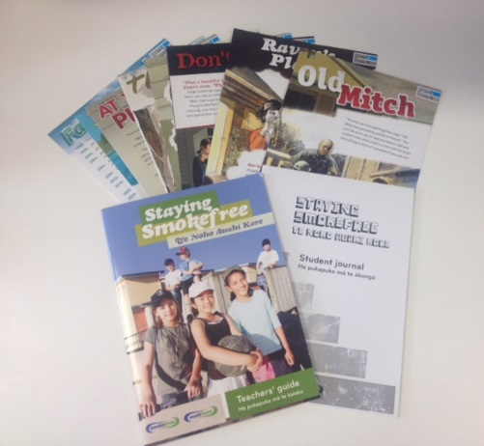 | SFS005 Staying Smokefree – Teachers’ Guide Pack  1x Staying Smokefree – Teachers’ Guide (with CD of the 8 audio stories)  1x Staying Smokefree Student Journal  8x laminated story and activity cards
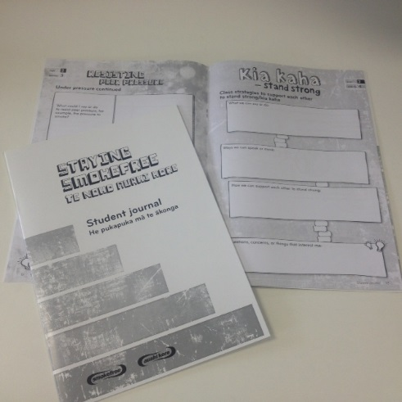 | SFS004 Staying Smokefree Student Journal  24 page black and white book for students to record their thoughts and observations while working through the Staying Smokefree activities.
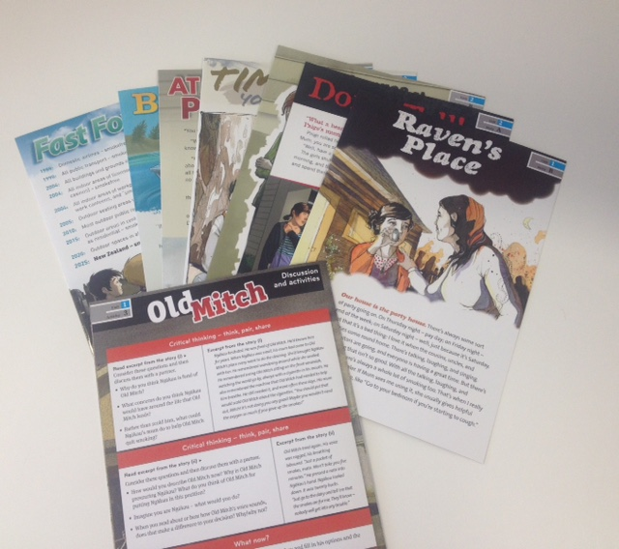 | SFS 011 Staying Smokefree Story Cards  8x laminated story and activity cards (to accompany the MP3 audio versions that are available for download smokefreeschools.org.nz)
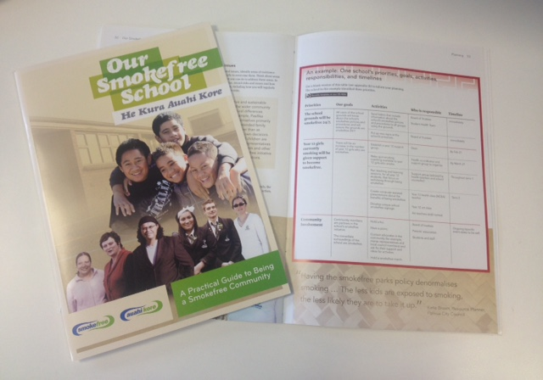 | Our Smokefree School – Practical Guide for being a Smokefree Community  44 page book, with CD-Rom containing Word and PDF planning templates, and a DVD showing members of school communities participating in interviews and activities in relation to being smokefree.
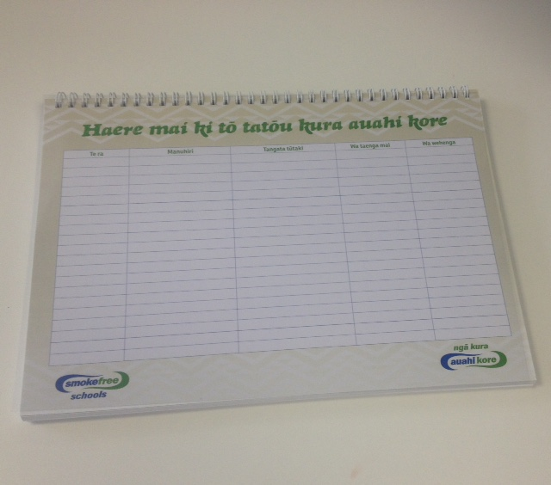 | SFS010-M School Visitor Book – Maori  Colour spiral bound, 50-page visitor book
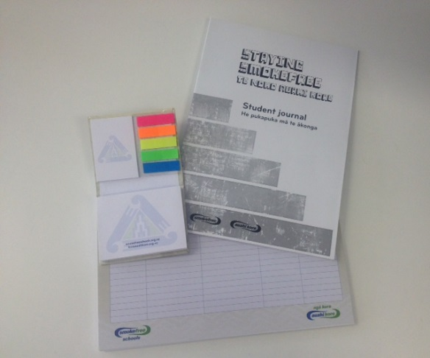 | SFS 026B Smokefree Schools Pack  30x Staying Smokefree Student Journals  1x Smokefree Schools post-it notebook  1x Visitors book (English)
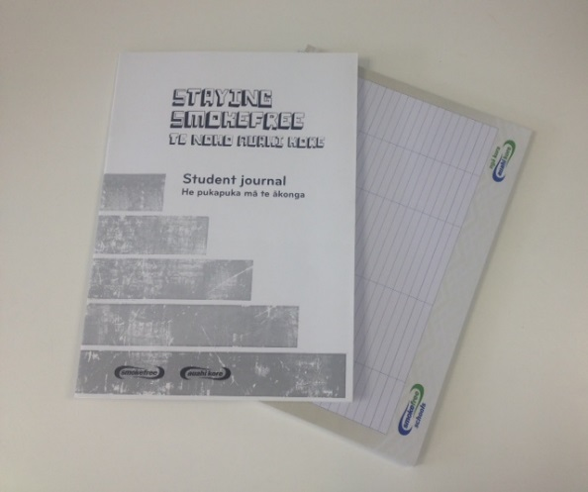 | SFS 026C Smokefree Schools Pack  30x Staying Smokefree Student Journals  1x Visitors book (English)

