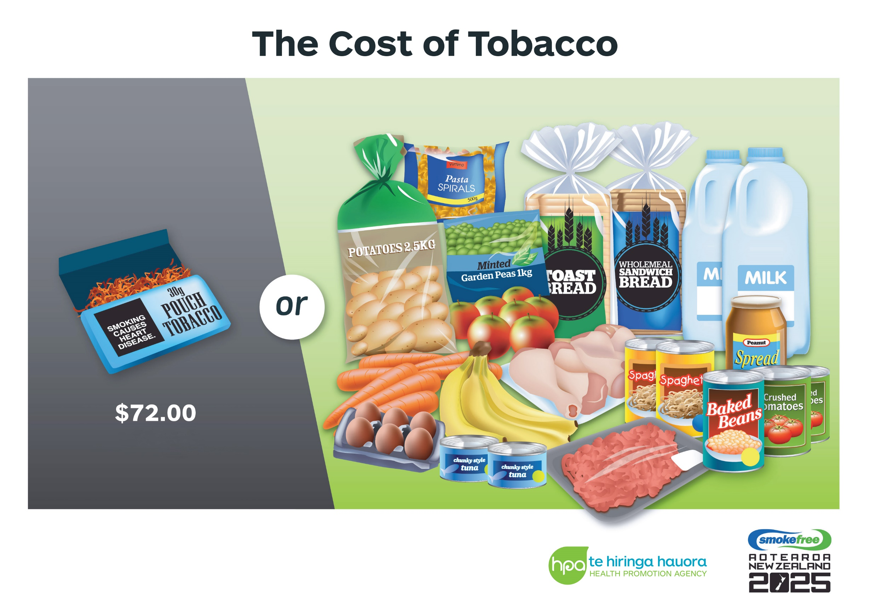

*Grocery items are based on supermarket brand prices at Countdown as of Jan 2021*

**Organisation contact details:**