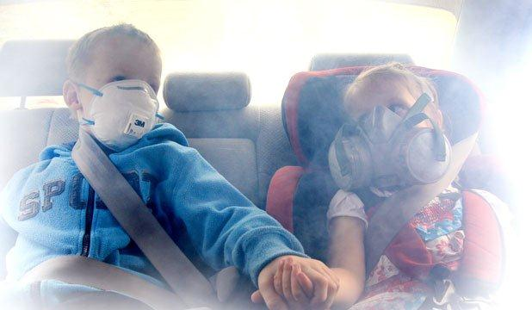 

* **Make a rule - your car and home are smokefree at all times for everyone**
* **Ask your family and whanau to support you by not smoking in your car or home (put stickers on doors and windows)**
* **Remove ashtrays in your home and lighters in your car**
* **Be a positive role model and don’t smoke around children. This means they are less likely to grow up to**

**be smokers themselves**



**SMOKEFREE HOMES & CARS**

When will our most vulnerable be protected?



