Waitangi Day Celebrating – Smoke-free Youth

Well what a fantastic day out at the Pak N Save Sports Park for Waitangi Day Celebrations. It was a windy start with the absence of the sides to the marquee!  If it wasn’t anchored down it blew away!

But once the sides arrived, we were able to get set-up properly and get stuck into our task of promoting the benefits of being smoke-free.

Although our focus was on “Smoke-free Youth” it soon became evident that our stall was attracting the whole whanau so we decided to make the most of the people actively coming to see us.  EVERYONE got a prize – Either a T-Shirt, A Cap or a Drink Bottle plus a Lip Balm and Pen!  Even the small children got to put their hand in the lucky dip if they brought an adult or a youth to the marquee.  It worked a treat!

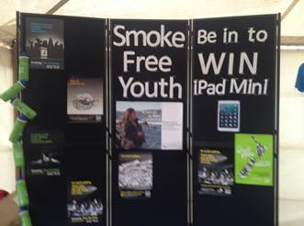    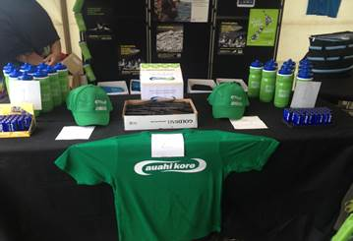

**The team provided Smoke-free advice to 339 people over the course of the day.**

(That was about 70 people per hour!  Yes we were busy… and no wonder my feet were sore at the end of the day)

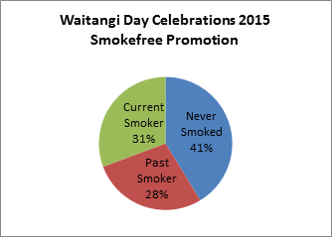   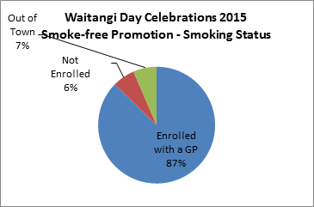

Approximately one third of all the people who visited our stall were current smokers.

All were offered brief advice and then referred to the Quit Line Team in the stall next door.

* 120 x 15-25 year olds participated in the promotion - 28% were current smokers, 53% had never smoked and 19% were past smokers
* 219 x 26 years and older participated in the promotion - 32% were current smokers, 35% had never smoked and 33% were past smokers

Part of participating in our promotion was for the person to consent to their information being sent to their general practice. This gave us the opportunity to promote enrolment for those who are not currently enrolled with a GP. All people who advised they were not enrolled were told someone would contact them shortly and help them to enrol with a GP. No high needs enrolment vouchers were able to be given out because of the organisers rules This isn’t a bad thing because it means we can actively follow up instead of hoping they will do something with it!

The iPad Mini winner was drawn at 3.00pm.  We are pleased to announce it went to Piri Taurima, of Flaxmere, an enrolled patient of Maraenui Medical Centre. Piri was contacted by phone and she came straight down and picked up her prize.  She had promotional photos taken with Wi and consented to having the photos put on the HBDHB face book page.

Finally, and most importantly… Thank you to the fantastic team!  What an effort – Wi (Master Organiser), Mabel, Lisa and Lauren who tirelessly worked hard out all day!

And thank you to our supporters, Liz who came early in the morning and helped us staple things down in the blustery wind, then bought us hot coffee and hot chocolate to warm us up.

Trish and Haley who also came and got stuck in for a few hours, also buying us a much need pep-up coffee during the busy day.  (Yes, we were spoilt alright!)

And finally to Penny Thompson & Johanna Wilson for providing us with a lovely packed lunch!

Our next task is to measure the impact of the day… when the Independent nurses take the information back to the practice they will do a number of things:

1. Update smoking status.  They will report on if the person already had a smoking status or not, and if it was up to date.
2. Record Brief Advice given to people who identified themselves as current smokers.
3. Update contact details.  Our forms included address, home number and cell phone number.  They will report whether these were up to date in the PMS.
4. The people who identified they were not enrolled with a general practice will be followed up and assisted to enrol.
5. Inconsistencies between who the person thinks they are enrolled with and if they are.  When collating the information I noted some anomalies such as Rhod Murry as their GP when he is now retired.  They may well still be enrolled with “Gascoigne Medical” though.

Kind Regards

Victoria Speers

PHO Performance Manager